MS.NET
Mini Project
Cargo-Manager-System (CMS)

Document Revision History

Date | Revision No. | Author | Summary of Changes
13-07-2017 | 1.0 | Pankaj Patil | Initial Draft

Table of Contents
Introduction 4
Setup Checklist 4
Instructions 4
Problem Statement 5
Objective 5
Abstract of the project 5
Functional components of the project 5
Technology used: 8
Implementation 9
Summary of the functionality to be built: 9
Guidelines on the functionality to be built: 9

Introduction
This document outlines a mini project for the .NET Line of Technology (LOT). The project is to develop Cargo Manager System. This document contains the requirements, work flow of the system and gives guidelines on how to build the functionality gradually in each of the course modules of the .NET LOT.

Setup Checklist
Minimum System Requirements
- Intel Pentium 4 and above Windows 2007, 2008 and 2010
- Memory 4 GB
- Internet Explorer 8.0 or higher
- SQL Server 2012 client and access to SQL Server 2012 server
- Visual Studio 2013

Instructions
- The code modules in the mini project should follow all the coding standards.
- Create a directory by your name in drive <drive>. In this directory, create a subdirectory MiniProject. Store your Project here.
- You can refer to your course material.
- You may also look up the help provided in the MSDN
- Since this project work will span over couple of months, you will need to take care of maintaining the code

Problem Statement

Objective

Development of Cargo Manager System
Abstract of the project
Cargo Manager is a comprehensive cargo management module, designed for addressing the areas of General cargo, Bulk cargo operations through Aviation. All the aspects of cargo like documentation handling, movement, and storage are addressed in this module.
Cargo Manager system will have following features:
- General Cargo Booking (Manifestation of cargo)
- Storing of Cargo (actual cargo weight, volume etc. are recorded)
- Generating the gate pass for bringing the cargo into the warehouse
- Marking the truck exit
- Delivery order for rejected or damaged cargo
- Generating gate pass for redelivery of cargo
- Housekeeping movements for maintenance i.e., moving the cargo from one place to another
- Extensive report and querying facilities

Users of the System will be: Cargo Manager Administrator
Role of Cargo Manager Administrator:
- Login to System
- Registration on System
- Search for Address
- Calculating Cargo Price
- Book a Cargo
- View Status of Cargo
- Cancel the Cargo

Functional components of the project
Application Architecture:
Distributed web applications traditionally to be designed and built across three logical tiers:
- Database Access Layer (DAL)
- Business Logic Layer (BLL)
- Presentation Layer
The DAL refers to the database itself, the stored procedures, and the component that provides an interface to the database. The BLL refers to the component that encapsulates all the business logic of the application. And, the Presentation layer refers to the web application pages.
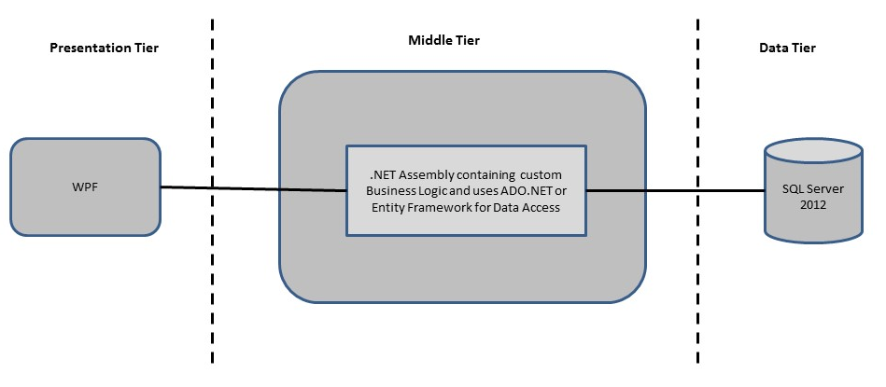
Design guidelines
- All the exceptions/errors to be captured and user friendly message to be displayed on the CommonError page.
- Data access layer of 3-tier use ADO.NET data access using SQL stored procedures - All the database interaction would be performed using Data Access Component. Most common methods in Data Access Component would be –
- Create Connection to the Database
- Create Command Object
- Set Command Type to Stored Procedure
- Create and Populate Parameters
- Execute the Command
- Close the Connection

Technology used:
    - Presentation Layer
      - WPF 4.5
    - Business Layer
      - Business Logic Components and Services :-
        - C# 5.0
    - Database Layer
      - Databases:-
        - SQL Server 2012

Implementation

Summary of the functionality to be built:
The participants need to develop the Cargo Manager System by building the functionality incrementally in each of the course modules of .NET LOT.
 | Sr. No |  | Course | Duration | Functionality to be built
 |  |  | Course | (in PDs) | Functionality to be built
 | 1 |  | MS SQL Server 2012 | 4 | Creating relevant database tables and stored procedures
 | 2 |  | NET Framework 4.5 + C# 5.0 | 7.5 | Developing Business components (C# classes)
 | 3 |  | ADO.NET 4.5 | 3 | Integrating the DAL ,BLL and PL
 | 4 |  | LINQ to Entity Framework | 2 | Creating data model and data context and using LINQ to entities
 | 5 |  | WPF 4.5 | 2 | Incorporating advanced UI functionality with WPF 4.5
 | 6 |  | Mini Project Presentation | 1 | The Mini Project Presentation day

Note: Saturday half day will be devoted for mini project

Guidelines on the functionality to be built:
The functionality and components to be built in each of the course modules of .NET LOT is as follows:
- Course: SQL Server 2012
This section describes some of the basic steps involved in designing and creation of the database for the application.
Create Data Model - identify the different tables and fields that we will need, which would later be used for building the rest of the application.
Database Schema - Taking these objects, we can easily identify our main tables in the database.
  - Create the following database tables with following fields: [make your assumptions in case you require few more fields]
      - Register : UserName, Password, PhoneNo, EmailId
      - CancelRequest : CustomerID, CancelRequestReason, Date
      - CustomerDetails : CustomerID,Name Address,PhoneNo,City,Email
      - Citys : CityID, CityName, State
      - CargoPrice : Weight, Price
      - CargoProductType : TypeID, ProductType
      - PlacePrice : Source,Destination,Price
      - ProductDetails : ProdId,ProdName,TypeID
      - CargoOrder : OrdederID, OrderDate, DeleveryDate, OrdPaymentID, EmployeeID, CustomerID
      - CargoOrderDetails : CargoOrderID, ProdID, UnitPrice, Qty, Discount, PaymentID, TotAmount, Source, Destination, DestinationAddr, FlightNo, Status
      - Payment : PaymentID, PayAccName, PayOrderID, PaymentDate, Amount , PaymentMethod
- Course: WPF 4.5
Develop the prototypes for following functionalities:
    - Login / Sign In: Login screen would display asking Cargo Manager user to enter ‘User Id’ & ‘Password’. If the supplied user credentials are valid the HomePage would be displayed, else appropriate Login error message would be displayed
    - Home Page: On successful user authentication (validation of userid/password provided by the user in login screen) the homepage would be displayed. The Homepage would contain below sections/contents:
Header section: The header section would be common across all the pages and would mainly have –
- Sign In Link – On click it would take to Login page
- Search: Search for information
Main content section: It would display generic Welcome message giving overview of the site. Should have menu for Administrator Employee, Customer
  - For Administrator :
        - Register a new Employee on Cargo Manager System
        - Delete an existing Employee on Cargo Manager System
        - Update an existing Employee on Cargo Manager System
        - Search for Employee and Customer.
        - Add new Cargo Type.
        - Update Cargo Type.
        - Update Places and Prices.
  - For Employee :
- Update self-Record on Cargo Manager System
- Search for Customer.
- Search for Cargo fare
- Search for Order
- Update Cargo Type.
- Update Places
- Update Customer
  - For Customer
    - User will get option to add, update its details
    - View the details of all Order Placed
- Course: C# 5.0 and ADO.NET 4.5
  - Develop business components (C# classes) for the following functionality:
    - Customer Class :- This class will contain methods which will allow to manage all Customers
    - Employee class :- This class will contain methods to manage Employee
    - CargoOrder Class :- This class will Contain methods which will allow to manage all Order Placed by Customer
    - CargoOrderDetails Class :- :- This class will Contain methods which will allow to manage all Order Placed by Customer
    - City Class :- This class will contain methods to manage City details
    - Product Class : This class will contain methods to manage Product
You need to create Layered Architecture which comprises of Presentation Layer (ssWPF), Business Logic Layer (C# Classes) and DAL Layer (Using ADO.Net 4.5 / Linq and Entity Framework)
DAL Layer of ADO.NET 4.5 will include all the required code snippets for CRUD Operations.
All the CRUD operations should use SQL Server Stored Procedures (For Insert, Update, Delete and Search).
The connectionString should be stored in the configuration file only.
OR
- Course : LINQ and EF
  - Use the database first approach and create the Entity data model consist of the following entities :
    - Customer Class :- This class will hold the basic details of the Customer
    - Employee Class :- This class will hold the details of Employee
    - CargoOrder Class :- This class will hold the basic details of Order Placed by Customer
    - CargoOrderDetails Class :- This class will hold the details of Order Placed by Customer
    - City Class :- This class will hold the details of City
    - Fare Class: - This class will hold the details of Fares.
    - Product Class :- This class will hold the details of Product
  - Use Data context to perform CRUD operations and Implement the required logic using LINQ (like retrieving data, sorting data, searching data etc).
- Course: ADO.NET 4.5 and WPF 4.5
  - Integrate all screens (WPF pages) with business components (C# classes) to complete the entire functionality

Project Evaluation Guidelines
The project it is to be evaluated based on the following five parameters:
- Proper Database Structure and UI designing as per the specifications –(15 Marks)
  - Proper Database Design and Stored Procedure
  - Visual look and feel of the UI
- Project Completion – (20 Marks)
  - Timely Completion of the project
  - Integration of all component of the system
- Defect free execution – (30 Marks)
  - Error free execution of individual modules and the whole system
  - Validation
  - Functionality as per the specified requirements
- Compliance of standard and guidelines – (15 Marks)
  - Appropriate comments entries
  - Adherence to naming conventions for classes, functions, variables and files
  - Simplicity of user interface and screen layouts
  - Maintainability of codes (for example, no one function should be more than 100 lines)
- Group Presentation and Query handling – (20 Marks)
  - Participants (Group of 3 to 4) to present the project with UML Diagrams(use case diagram and one of the sequence or activity diagram) and PPT

